October 16, 2012

Dear Families,

Tomorrow will be your child’s last day of MEAP testing unless they have been absent in the last two weeks. I think we are all looking forward to uninterrupted learning time! Please compliment your child. The class has been taking this testing seriously and using strategies.

C:\Users\pwalcott\AppData\Local\Microsoft\Windows\Temporary Internet Files\Content.IE5\538AQ7K9\MC900151433[1].wmfIn class we are reading about historical figures so choosing one for the wax museum presentations will be easy! The students have lots in mind, but it would be preferred to keep it before President Lincoln’s time. Students will have their selection made by next Friday, October 26. Please continue to have conversations about history.

Dates to Remember

Friday, October 19 Last day for book orders

Friday, October 26 Wax Museum Selection Made

Penny Carnival Games in PM

Thursday, November 1 Fundraiser Pick-Up 3:15 –5:15pm, Volunteers Needed

Friday, November 2 Native American Celebration, Cooking Volunteers Needed

November 19 & 20 Parent-Teacher Conferences

We can use many cooking volunteers for our Native American celebration. Mr. VK assures me no recipe is complicated. It is something you can put together with your fifth grader the night before and drop off at school Friday, November 2.

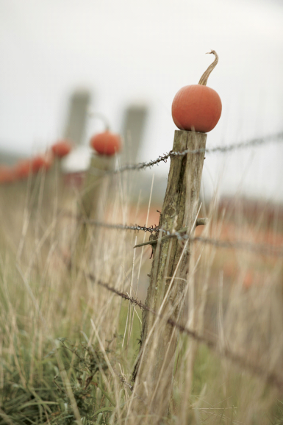Please ask over the next few weeks how our pumpkin experiment is going. Students began writing their hypothesis yesterday!

Parent-teacher conferences are only a few weeks away, November 19 and 20. If you have any issue let’s talk now. Also please don’t worry if I contact you in the next few weeks. I only want to inform you of any strategies I am using with your child to increase their learning.

REMINDERS FROM THE LAST NOTE

• We will be taking a 22 mile trip at the end of the school year. So getting a few mile trip in is good for everyone.

• Sleep-overs are another thing to practice. If your child has never slept away from you the parent, now is a good time to try it out with grandparents or friends in a familiar environment before we travel to the Museum of Science and Industry for the snoozeum experience.

• Talk to you about their learning while they are showing you their agenda and having you initial! Every repetition of their learning makes it stronger.

Enjoy the week!

Sincerely,

Patti Walcott

[pwalcott@zps.org](mailto:pwalcott@zps.org)

Office 748-3375

Voicemail 748.4777x2719

mrswalcott.weebly.com/